C4- S4-PRACTICE

**Combining data** from multiple tables using MULTIPLE **JOINS**

1. This exercise is based on given ONLINE database:

<https://www.w3schools.com/sql/trysql.asp?filename=trysql_select_where>

* Test your queries on the online editor
* Copy / paste your answer for each question on this document

**Q1**: Write the query to display for each order ID, the name of the customer

As example:

|  |  |
| --- | --- |
| OrderID | CustomerName |
| 10248 | Wilman Kala |
| 10249 | Tradição Hipermercados |
| 10250 | Hanari Carnes |
| 10251 | Victuailles en stock |
| 10252 | Suprêmes délices |

Your answer:

SELECT Orders.OrderID, Customers.CustomerName from orders inner join Customers on Orders.CustomerID = Customers.CustomerID;

**Q2:** Display the products (no duplicate) the customer "Familia Arquibaldo" has bought.

Your answer:

**Q3:** Display the 10 products names which are the MOST SOLD products

Your answer:

**Q4:** Display all products shipped by "Speedy Express"

Your answer:

Q5: Display all customers and suppliers who belong to the same country.

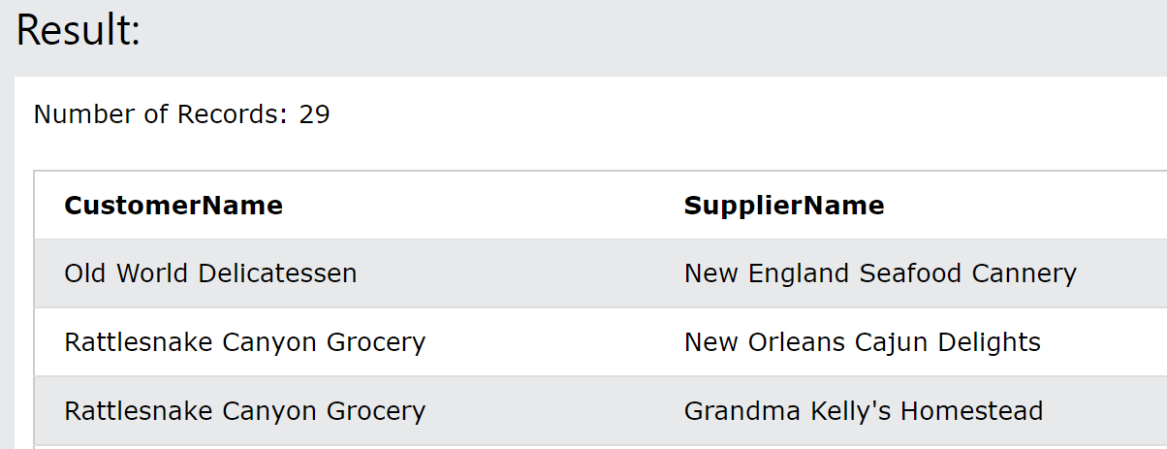

Your answer:

1. Mommy Hospital want to store information about :

* **Doctors** that are described by their first name, last name, **salary**, **phone** and **email address.**
* **Patients** that are described by their first name, last name, **phone, address, job and** Sickness **description.** 

Here is some more information on appointment process:

* a patient can make many appointments with many doctors.

**Q1** – What is the relation between Doctors and Patients? why?

………………………………………………………………………………………….

**Q2** - Do you create an associative table? why?

……………………………………………………………………………………….

**Q3 -** Design the ERD of Mommy Hospital database

|  |  |  |
| --- | --- | --- |
| …………………………….. | | |
| ……... | …………..  …………. | ………..  ………. |

|  |  |  |
| --- | --- | --- |
| …………………………….. | | |
| ……... | …………..  …………. | ………..  ………… |

**Q4 –** Implement this database in MySQL by using phpmyAdmin

**Q5 –** Insert the following in the right table

1. Patient Jonh Mongly plan to meet doctor on 20 August, 2021 with doctor Smit at 8am.

2. On the same day, Jonh Mongly wanted to meet doctor Sundra at 10am.

3. Today Makar’s son is not well. They are going to meet doctor Bun Long as soon as possible.

4. Patient Seyha met doctor Bun Long last year on 10 June 2020.